Setting up ECS
- We'll need to define our Container definition, Task definition, Service, and Cluster

Creating Task Definition
Step 1:
On AWS Console Look up ECS
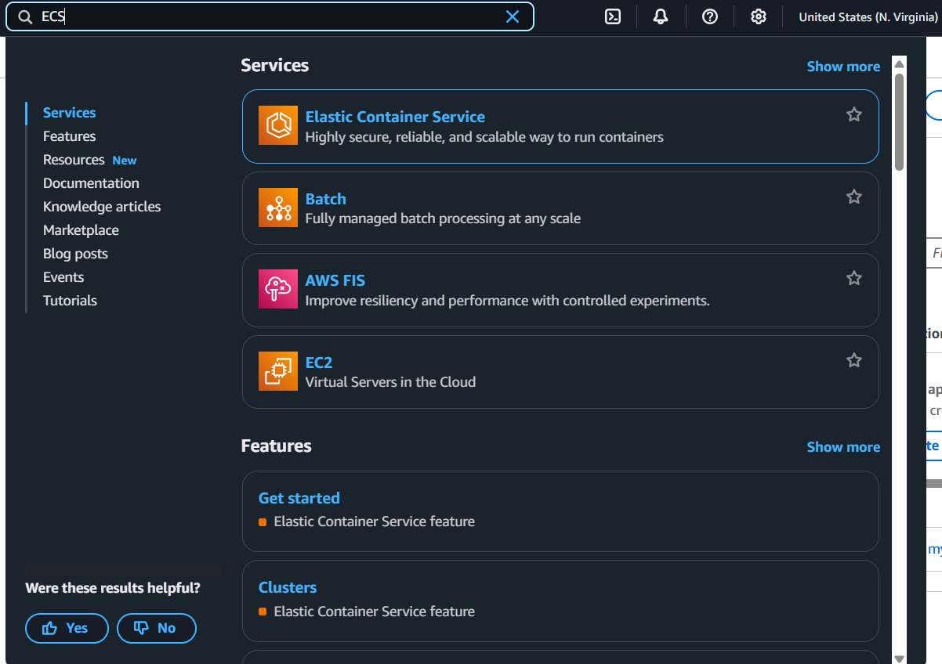
Step 2:
Select Task definitions on the sidebar
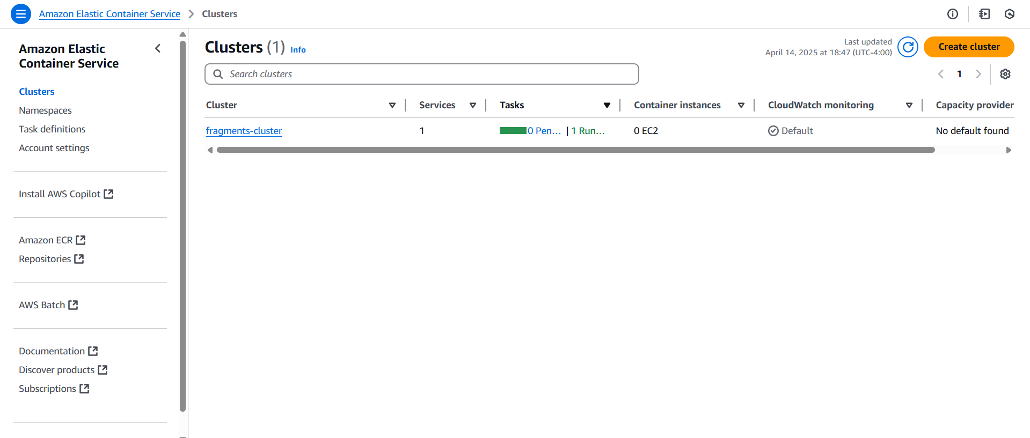
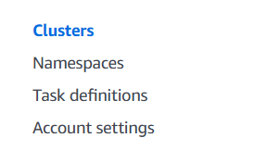
Step 3:
Select Create new task definition Create new task definition
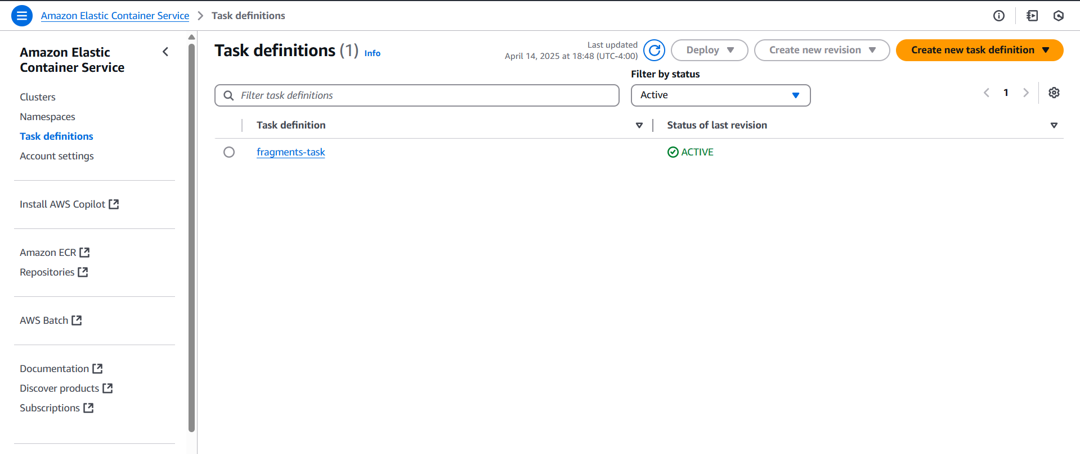
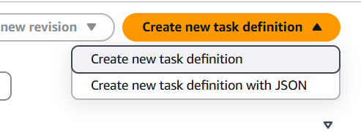
Step 4:
Set the name of the task
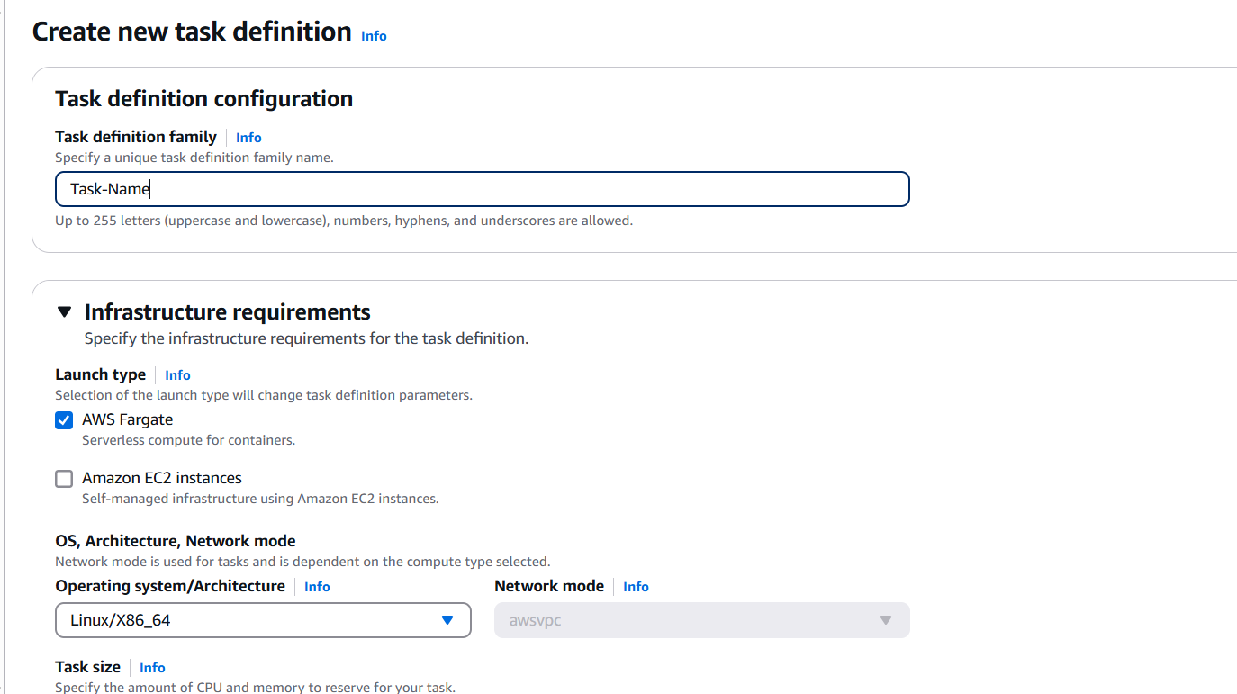
Step 5:
Set the infrastructure requirements
Here’s what all the options are
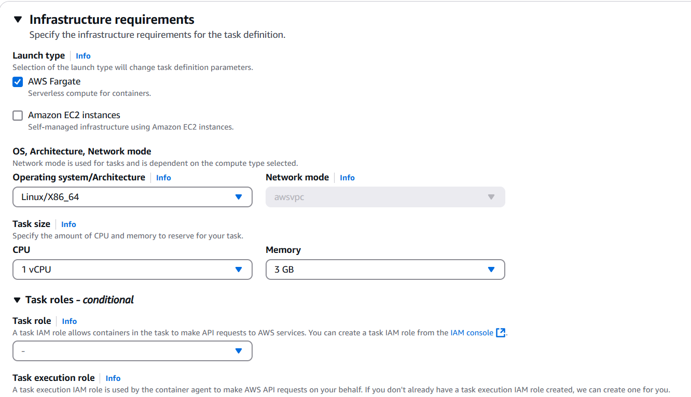
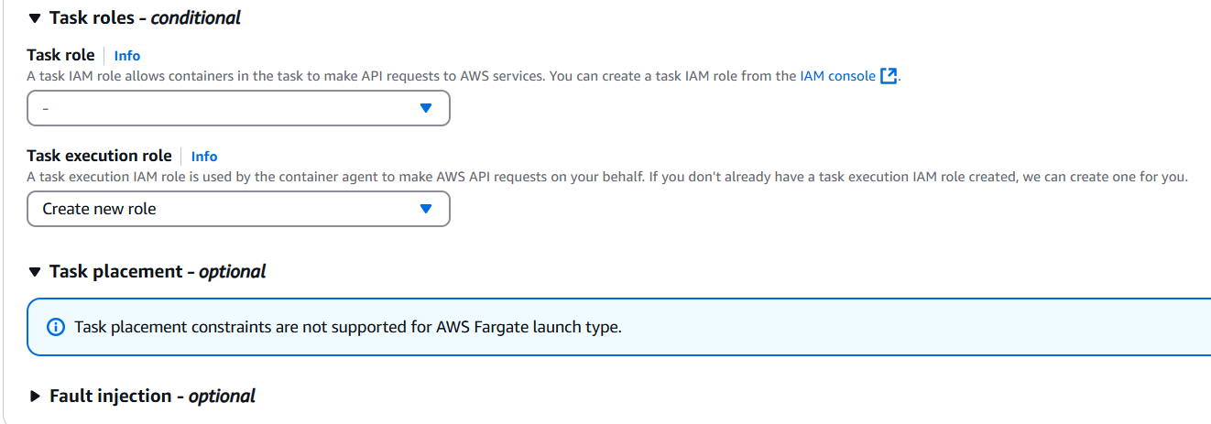
Ex. Setting up Fargate with modest needs
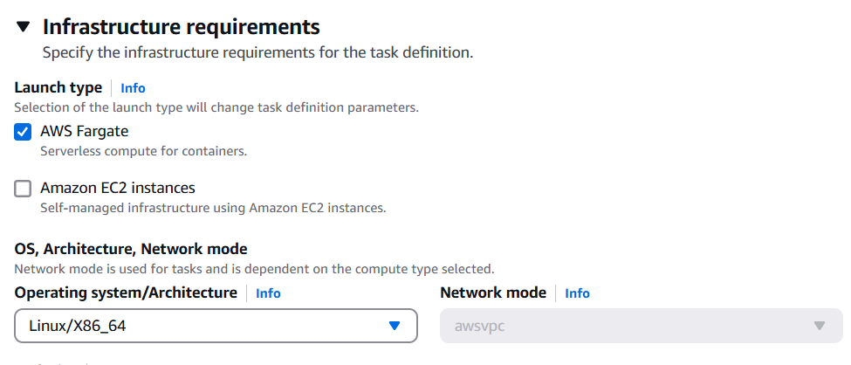
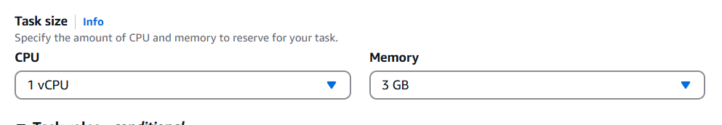
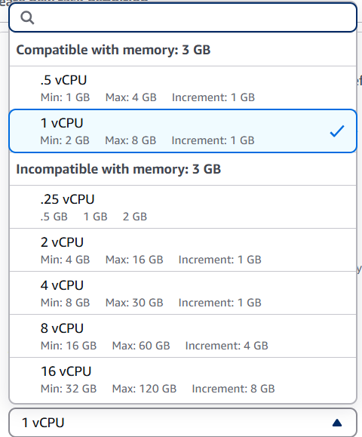
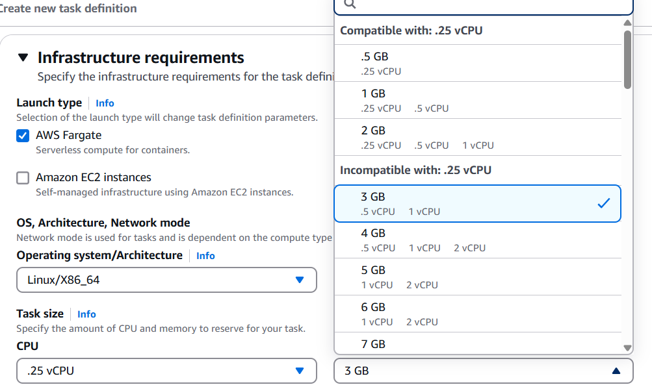
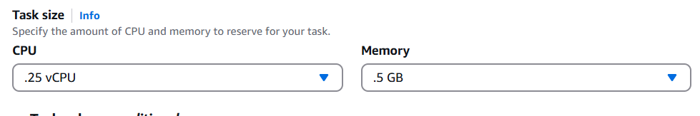
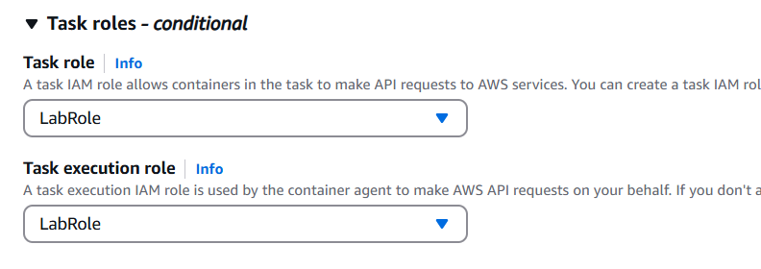
Step 6:
Set the Container – 1 properties
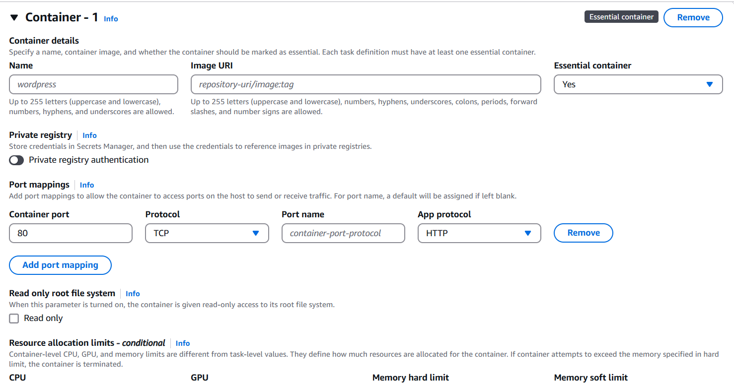
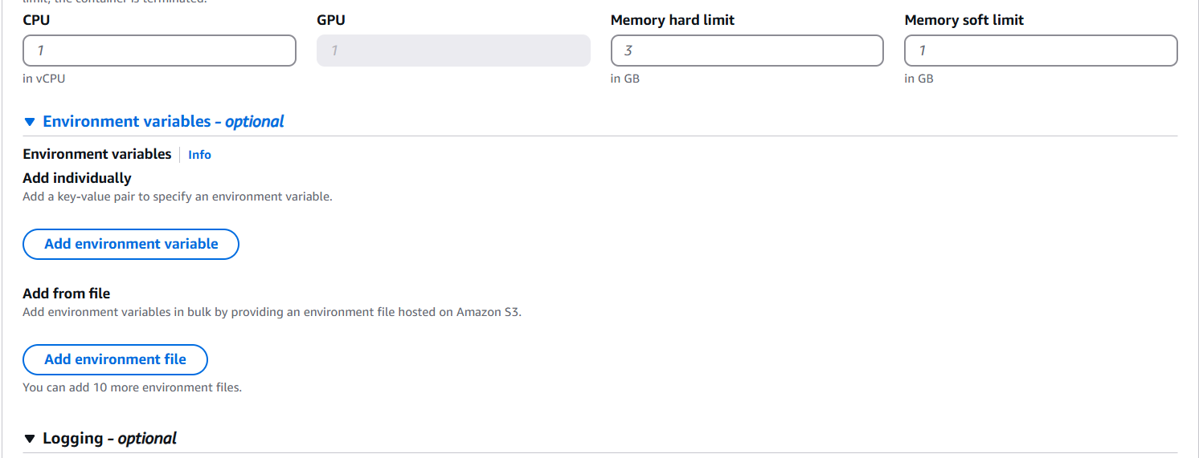
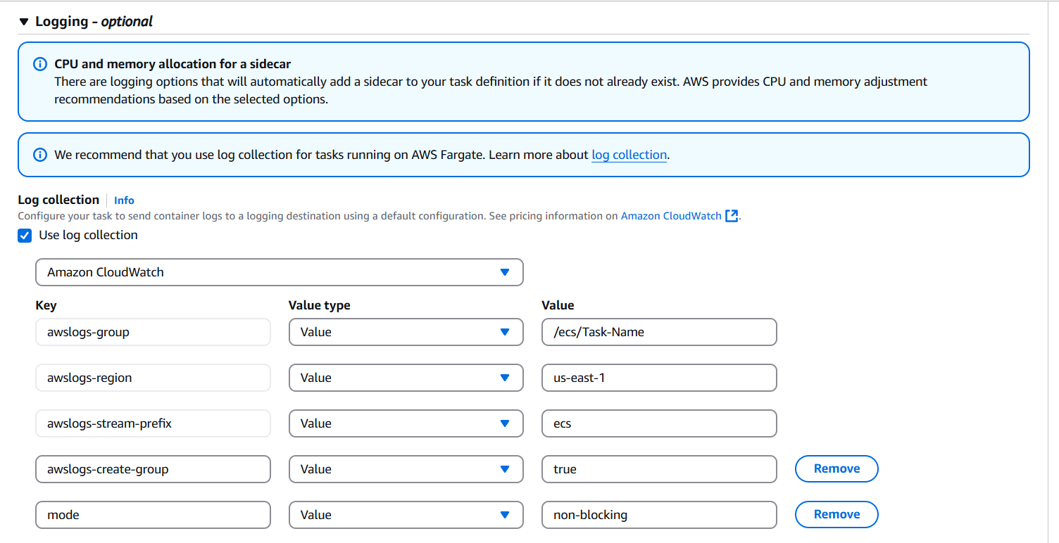
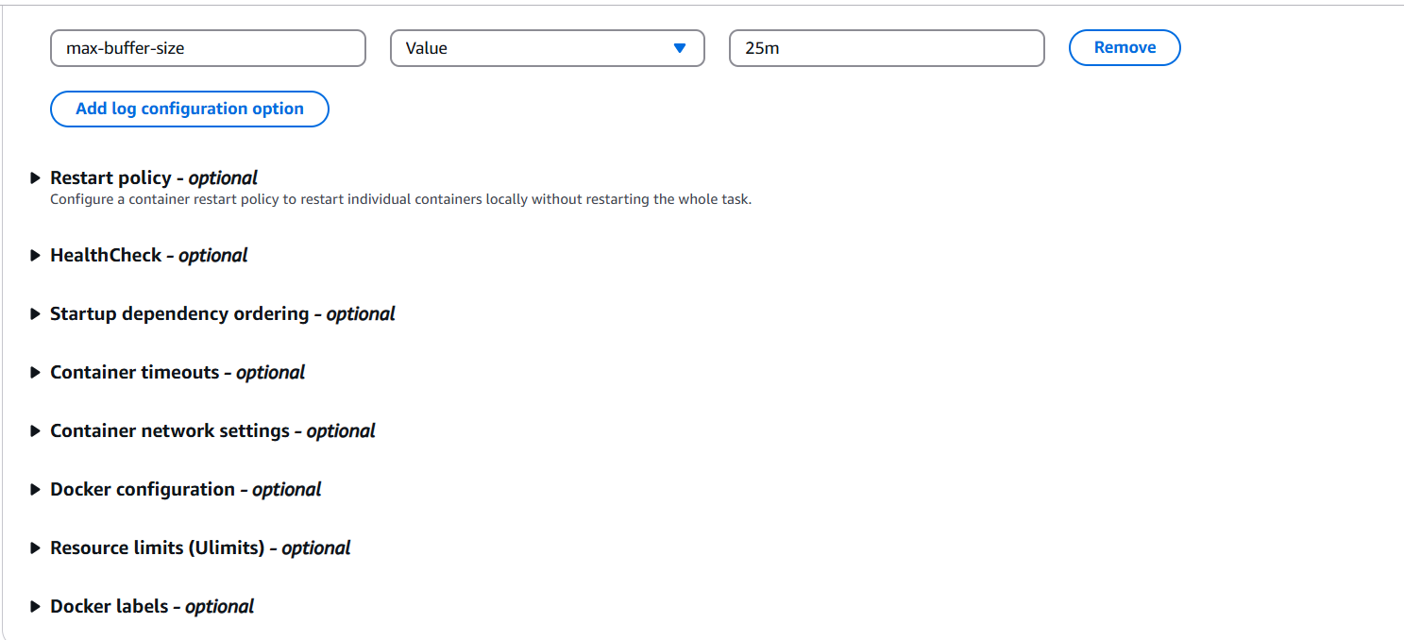

Adding Env:
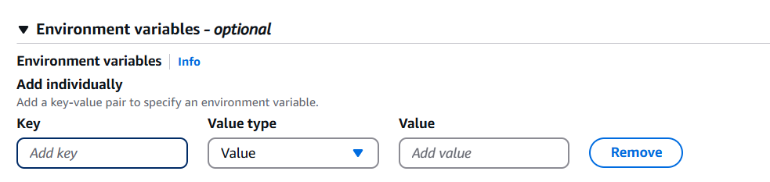
Optional: Add another Container or Modify Storage
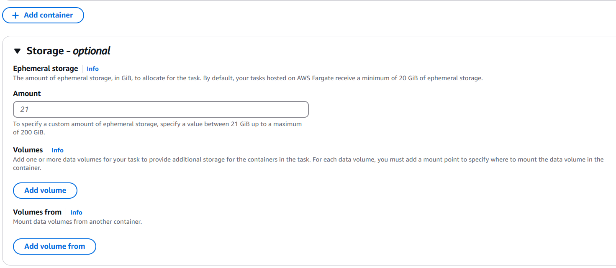
Optional: Add Monitoring and or Tags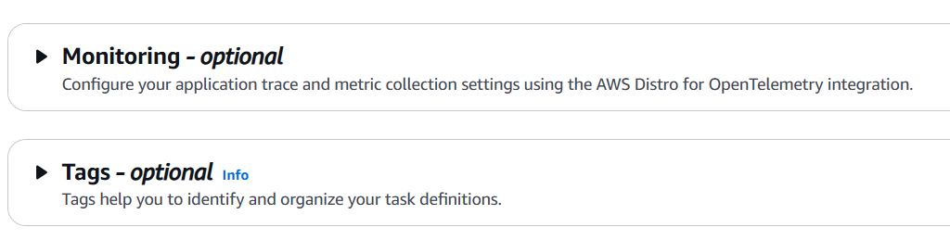
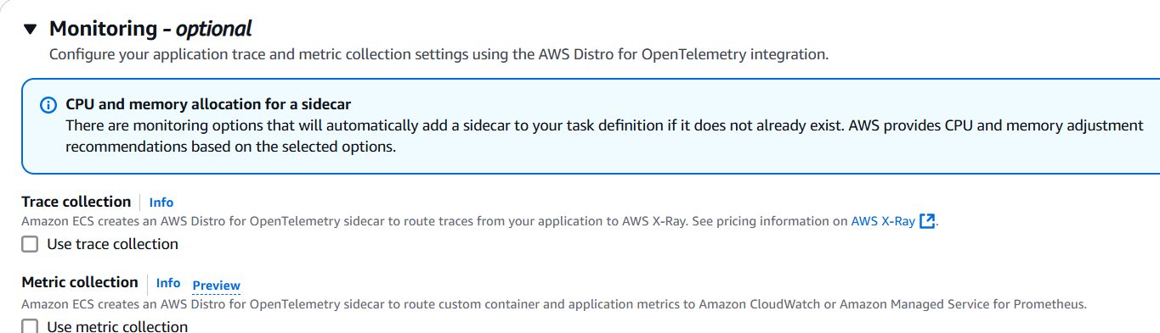
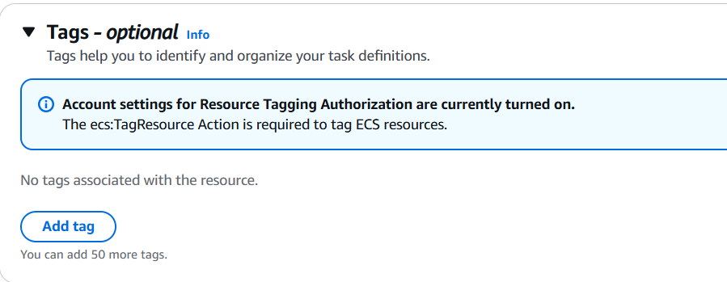

Step 7:
Click Create
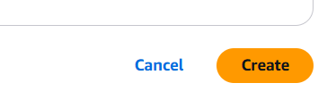

Creating Cluster:
Step 1:
Click Clusters on the sidebar
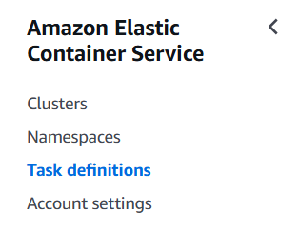
Step 2:
Click Create Cluster
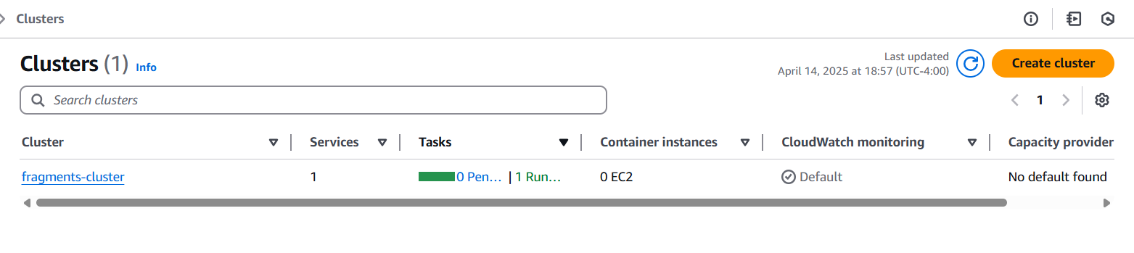
Step 3:
Set the Cluster name
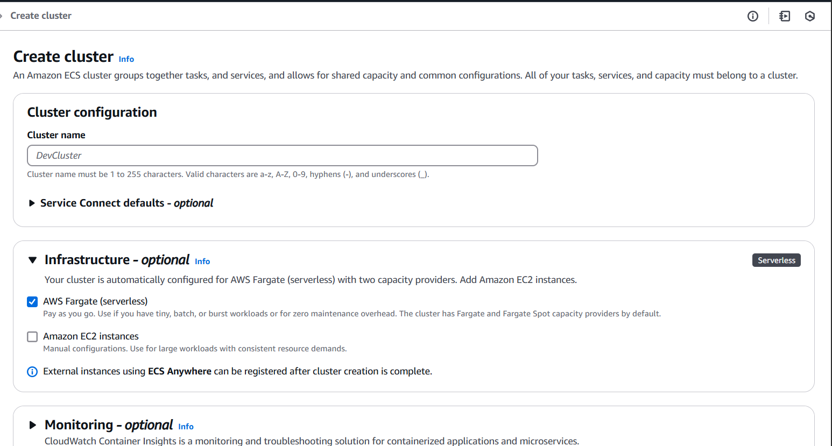
Optional parts:
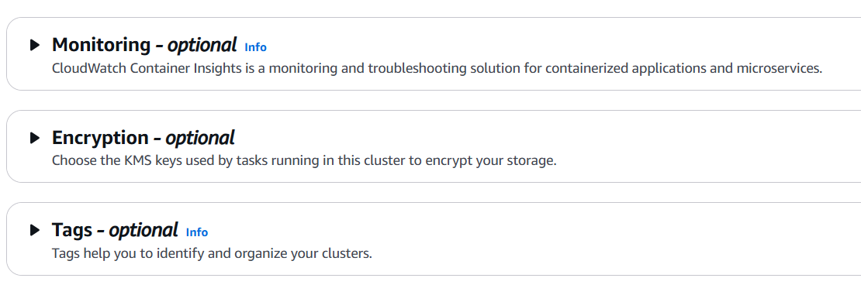
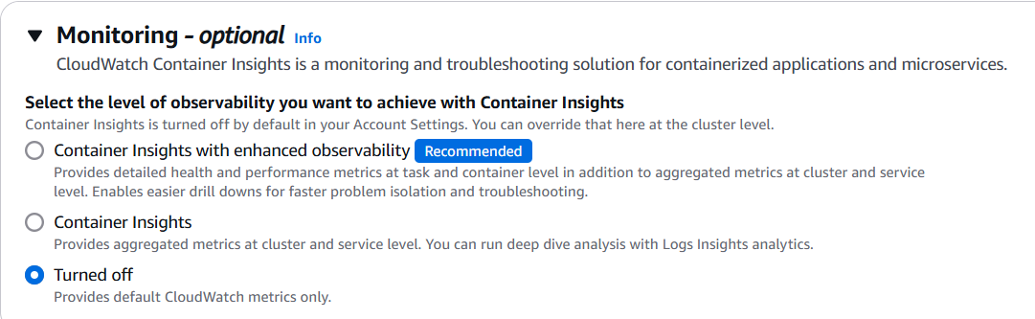
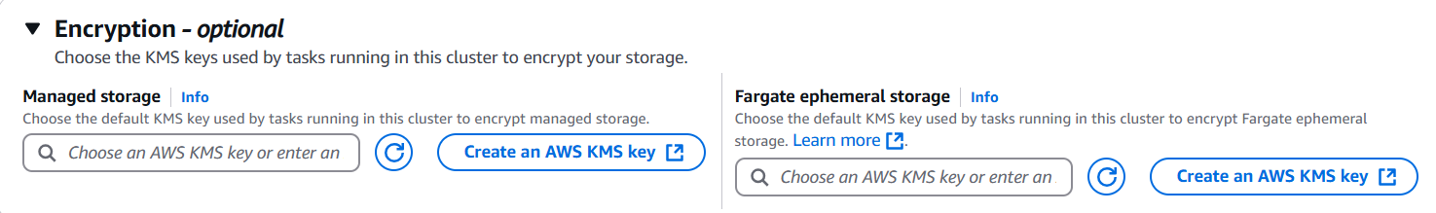
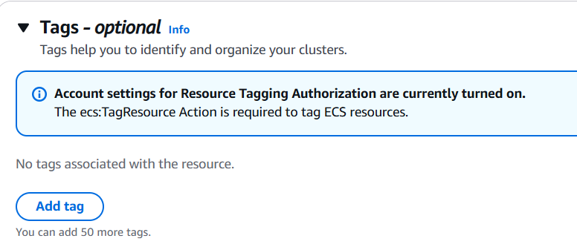

Creating Service / Cluster definition
Step 1:
Select the cluster
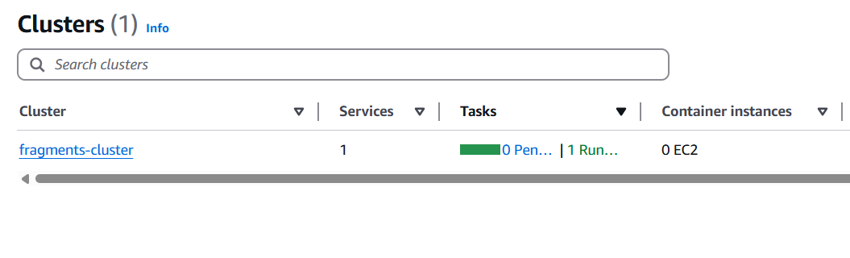
Step 2:
Under the Services tab, click the Create
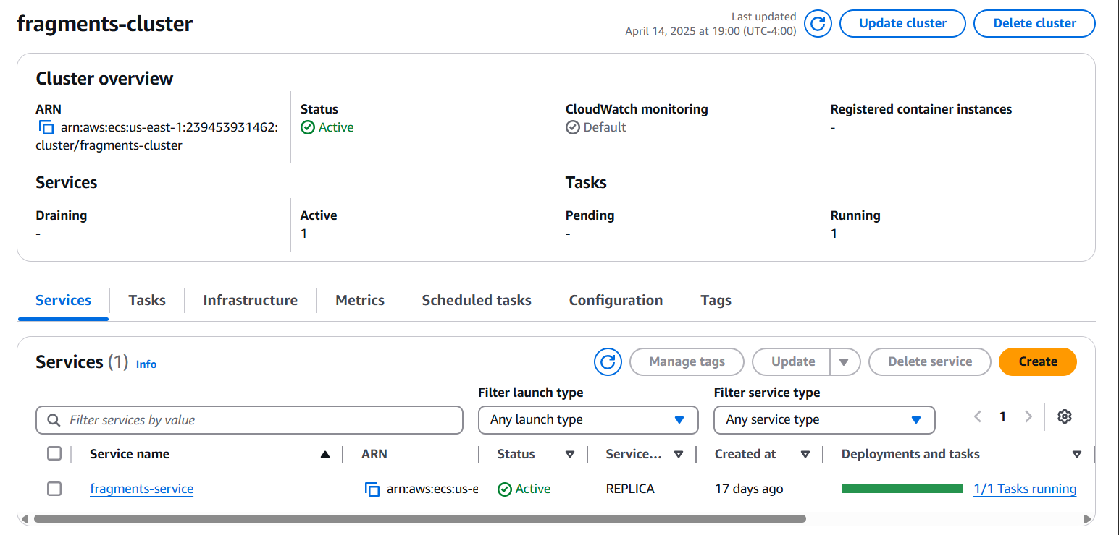
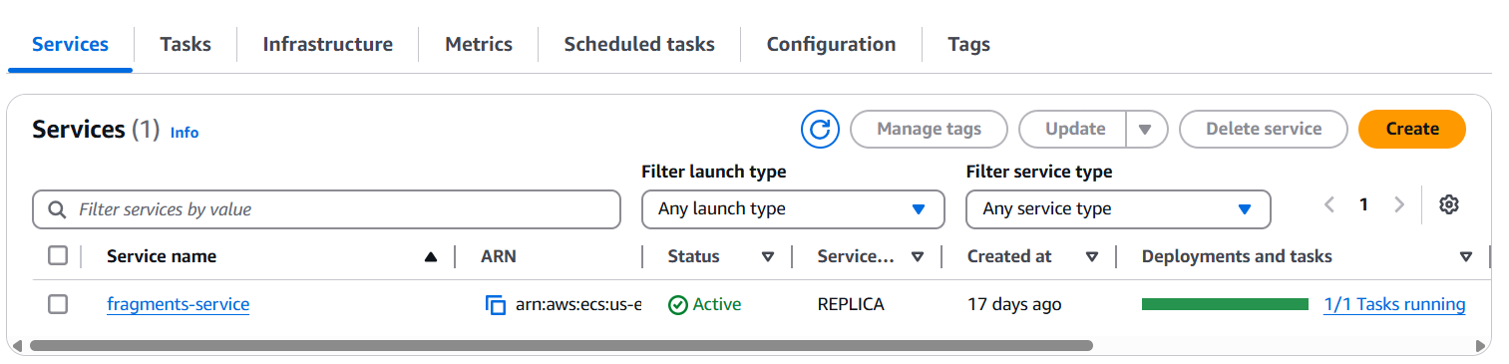
Step 3:
Name the Cluster
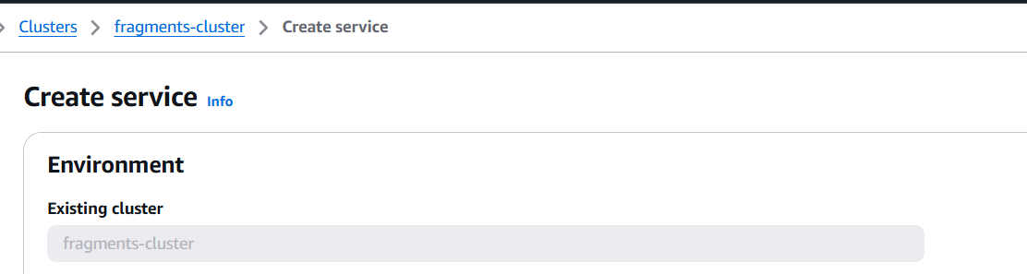
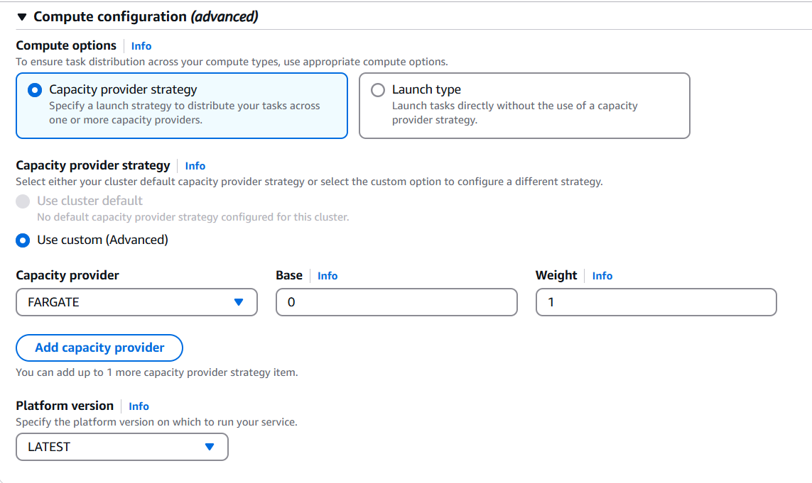
Step 4:
Add Deployment Configurations
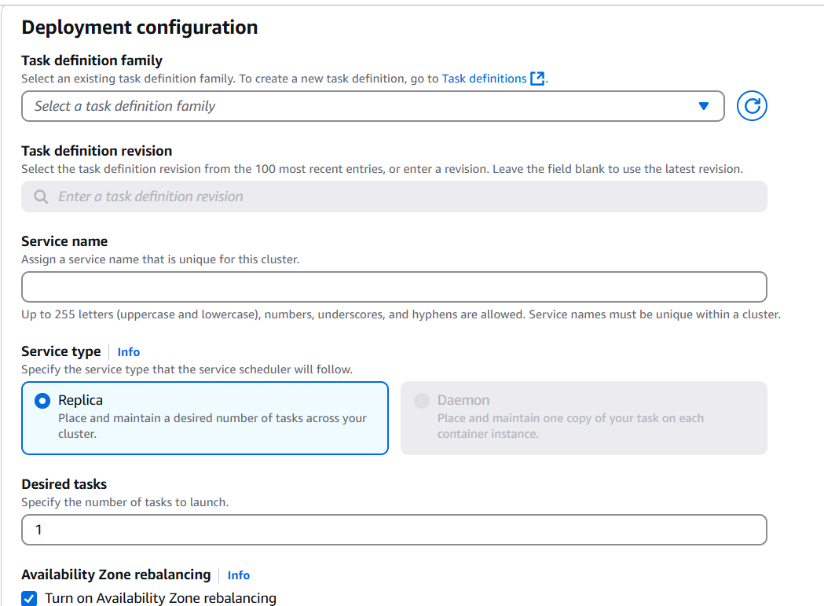
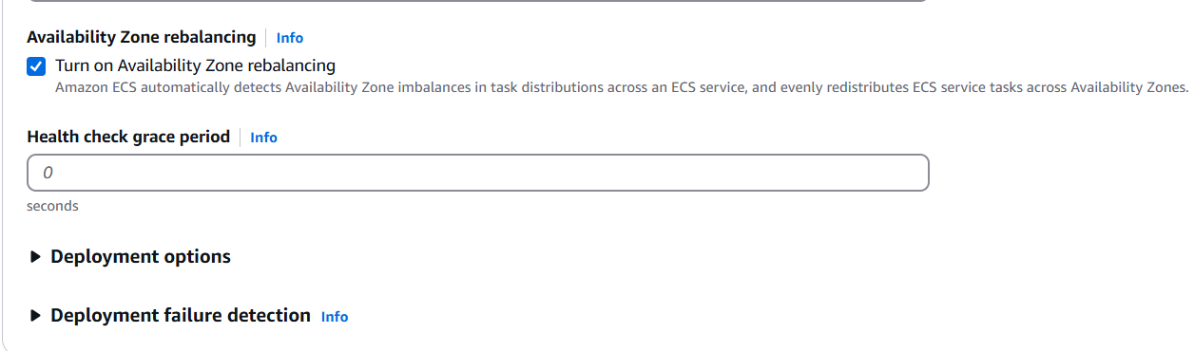
Step 5:
Set Task Definition Family to the task definition you created
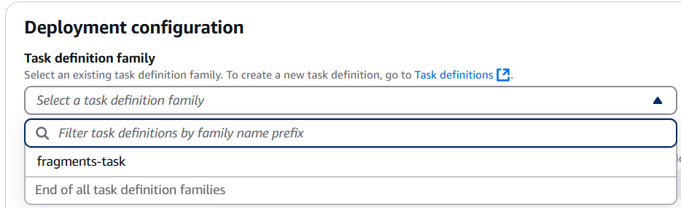

Step 6:
Name the Service
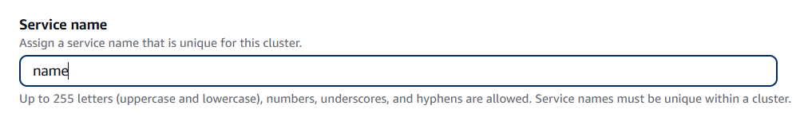

Step 7:
Set the service type
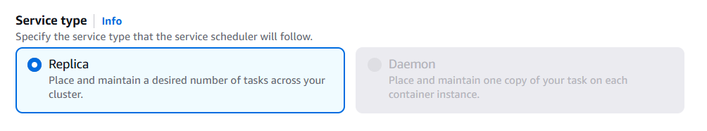

Step 8:
Add Networking configurations
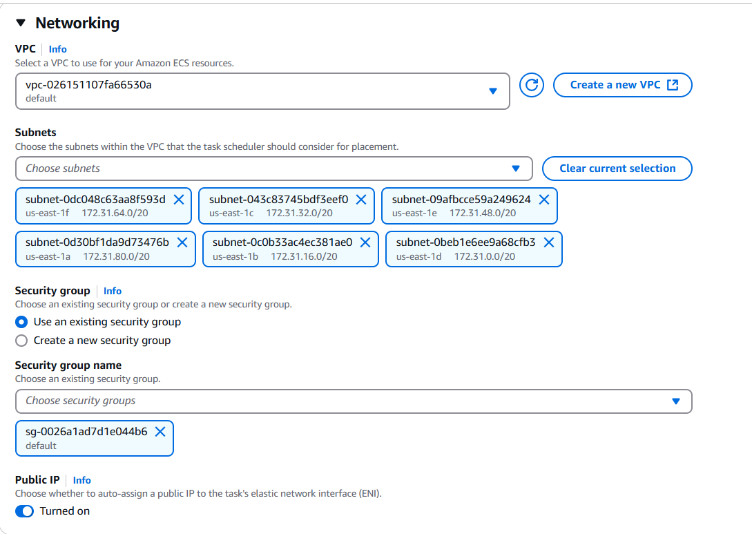
Step 9:
Create a custom security Group
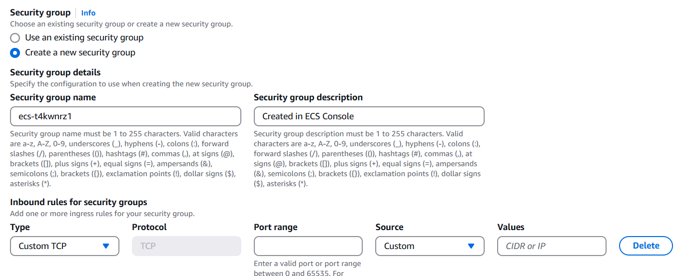
Ex:
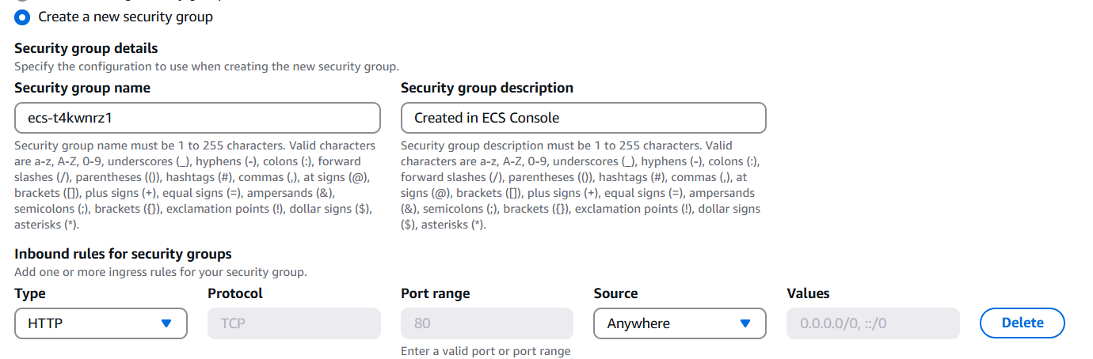

Step 10:
Use the Load balancing
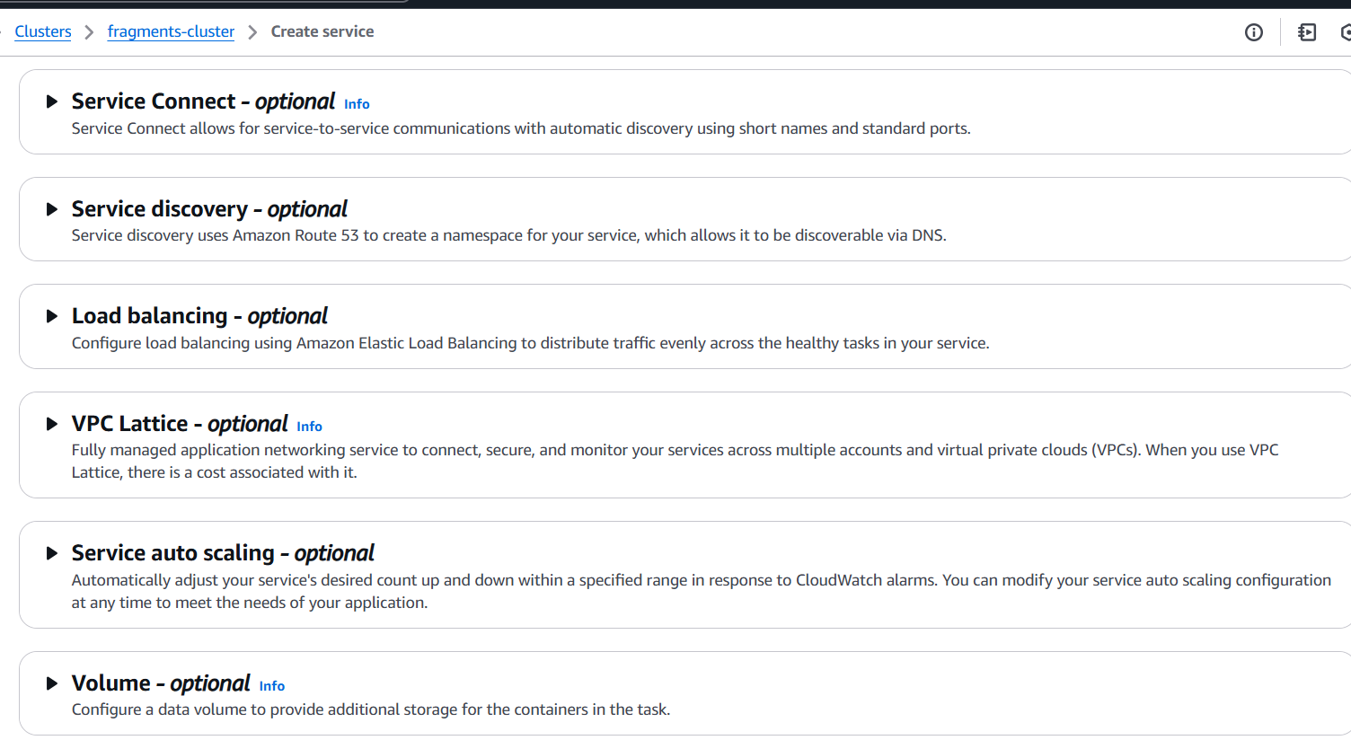
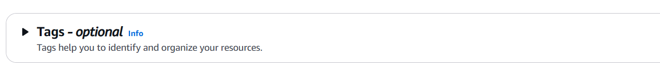

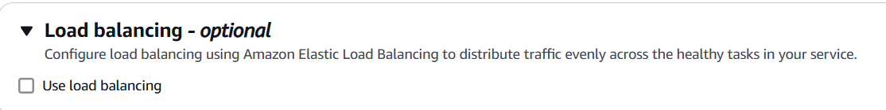
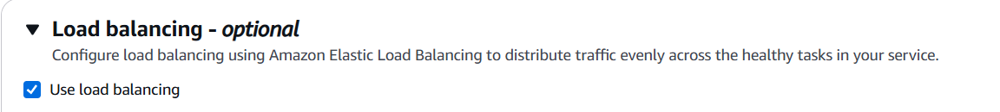

Step 11:
Configure the load balancer
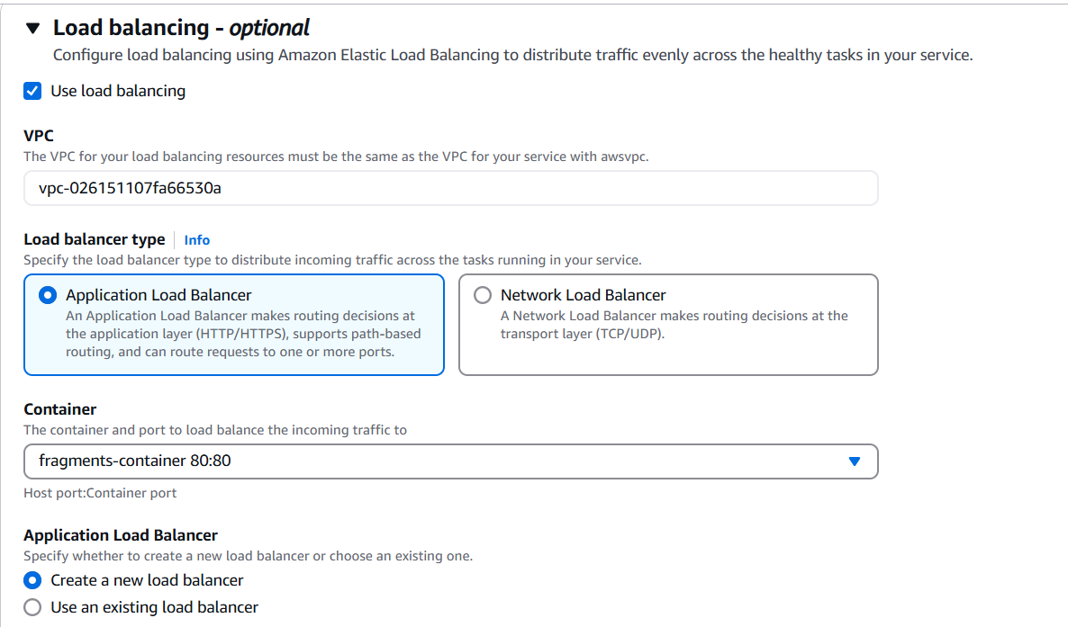
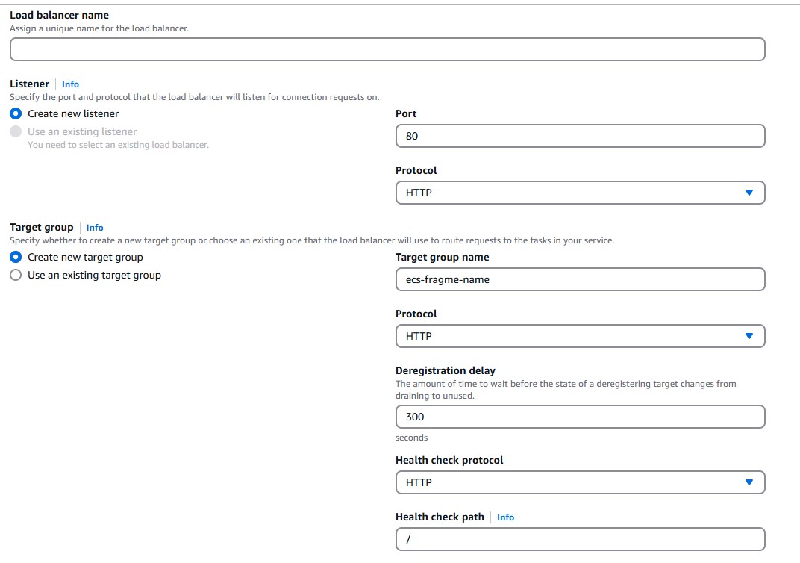
Step 12:
Click Create
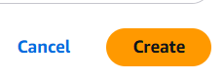n

